

ASSET VERIFICATION AND RECORDING TOOL KIT


Plot 31, Bukoto Street
P.O Box 7657, Kampala, Uganda
+256 (0) 39 2000216/0772525235
email: cpa@cpa.ug

www.cpa.com

August to September 2026

VERIFICATION DETAILS

NAME OF THE REGION: | WESTERN
SUB-REGION: | TOORO
Name of Local Government | KYENJOJO DISTRICT
VERIFIER PARTICULARS
Full name | KATO CHARLES
Contact/ email and Telephone | 0755790124 & katoc560@gmail.com
Supervisor/ Sub team leader
Name | Prof: MBONIGABA DEPAUL
Contact | 0788483159
Date of submission | 06/09/2026

HEALTH CENTRES
INFORMANT INTERVIEW/DISCUSSION GUIDE (INCHARGE OR RESPONSIBLE PERSON)

Name of Health Centre: MYERI HC III

1a | Does the Facility have a record of all assets provided under UgIFT.  (Obtain a record and verify if it has the costs and numbers supplied | The list was available but didn’t have costs as well as asset numbers and expected lifetime for the equipment.
1b | If not ask how many were supplied and when.

2 | How does this facility Maintain (repair/service/replace) the assets provided under Ugift

The facility funds minor repairs using PHC funds; however, the huge cost of repairs cannot be managed by inadequate PHC funds.

3 | Does the facility take regular record about functionality/ or breakdown of the assets provided? | Yes, the facility had a list of the items available

The facility had an asset register, however there was no information about the functionality of the available equipment.

4 | How has the UgIFT support helped in service delivery in the area, any issues, challenges and any recommendations for better program implementation.

The incharge expressed gratitude to the UGIFT program funding the facility with equipment, improving staff housing and easing their work by providing equipment which greatly improved service delivery to the communities.
He recommended that the health facility needs should be consulted, before procurement and their input be considered before delivering equipment because sometimes, they are provided with excess equipment/ oversupply, furniture with short life span and storage becomes a problem.

PROCEED TO VERIFICATION AFTER THIS DISCUSSION

Health centre checklist

NAME OF LG: KYENJOJO DISTRICT NAME OF HEALTH FACILITY: MYERI HC III

Equipment/ Item | Department | Asset Number | Item  Description | Life in Months | Tag Number (engrave no.) | Date Of Purchase | Date Placed in Service | Recoverable cost | Cost | Acc Dep Cost | Net Book Value | Ytd Deprn | Equipment status | Remarks
B.P. Machine, Digital | health |  | sinoheart, model BA-801 sionocare bp machine |  | Not engraved |  | 22/09/2025 |  |  |  |  |  | Functional
 | Health |  | Sinocare bp machine, Model AES-U111 |  | Not engraved |  | 22/09/2025 |  |  |  |  |  | Functional
B.P. Machine (Aneroid wall mounted) | health |  | BP machine (aneroid wall mounted, Navy blue in colour |  | Not engraved |  | 22/09/2025 |  |  |  |  |  | Not functional | Machines are in the store not yet used
 | health |  | BP machine (aneroid wall mounted, Navy blue in colour |  | Not engraved |  | 22/09/2025 |  |  |  |  |  | Not functional | Machines are in the store not yet used
Autoclave 20 Liters., Duo Operated | health |  | Autoclave, external heated, 20liters |  | Not engraved |  | 22/09/2025 |  |  |  |  |  | functional
Bowl, Kick | Health |  | 1 bowl kick |  | Not engraved |  | 22/09/2025 |  |  |  |  |  | functional
Bowl Stand | Health |  | Stainless steel movable |  | Not engraved |  | 22/09/2025 |  |  |  |  |  | functional
 | health |  | Stainless steel movable |  |  |  | 22/09/2025 |  |  |  |  |  | functional
 | health |  | Stainless steel movable |  |  |  | 22/09/2025 |  |  |  |  |  | functional
Counting chamber Neubauer- Improved
 | health |  | Rectangular shaped apparatus with droppers |  | Not engraved |  | 22/09/2025 |  |  |  |  |  | Not functional | The equipment was in store
 | Health |  | Rectangular shaped apparatus with droppers |  |  |  | 22/09/2025 |  |  |  |  |  | Not functional | The equipment was in store
Cupboard Steel, Lockable | Health
 | Health |  | 1 cupboard steel with transparent glass, lockable (grey) |  | Not |  | 22/09/2025 |  |  |  |  |  | Functional | 2 cupboards were delivered to the health facility and are being used to store unused instrument sets.
 | Health |  | 1 cupboard steel with transparent glass, lockable (grey) |  | Not |  | 22/09/2025 |  |  |  |  |  | functional
Drip Stand
 | Health |  | 1 Drip stand, stainless steel attached to the beds |  | Not engraved |  | 22/09/2025 |  |  |  |  |  | Functional | 4 drip stands that are in the store
 | Health |  | Drip stand, MK-ISO, SN MM220210C01 |  | Not engraved |  | 22/09/2025 |  |  |  |  |  | Functional | 4 drip stands that are in the store
 | Health |  | Drip stand, MK-ISO, SN MM220210C01 |  | Not engraved |  | 22/09/2025 |  |  |  |  |  | Functional | 4 drip stands that are in the store
 | Health |  | Drip stand, MK-ISO, SN MM220210C01 |  | Not engraved |  | 22/09/2025 |  |  |  |  |  | Functional | 4 drip stands that are in the store
 | Health |  | Drip stand, MK-ISO, SN MM220210C01 |  | Not engraved |  | 22/09/2025 |  |  |  |  |  | Not functional | 4 drip stands that are in the store
 | Health |  | Drip stand, MK-ISO, SN MM220210C01 |  | Not engraved |  | 22/09/2025 |  |  |  |  |  | Not functional | 4 drip stands that are in the store
 | Health |  | Drip stand, MK-ISO, SN MM220210C01 |  | Not engraved |  | 22/09/2025 |  |  |  |  |  | Not functional
 | Health |  | Drip stand, MK-ISO, SN MM220210C01 |  | Not engraved |  | 22/09/2025 |  |  |  |  |  | Not functional
ESR Stand | health |  | 1 ESR was available with sedimentation tubes |  | Not engraved |  | 22/09/2025 |  |  |  |  |  | functional | The equipment is available in the lab
Examination Couch
 | Health |  | Examination couch metallic with a mattress |  | Not engraved |  | 22/09/2025 |  |  |  |  |  | functional
 | Health |  | Examination couch metallic with a mattress |  | Not engraved |  | 22/09/2025 |  |  |  |  |  | functional
Examination light,LED | health |  | LED examination light |  | Not engraved |  | 22/09/2025 |  |  |  |  |  | functional
 | Health |  | LED examination light |  | Not engraved |  | 22/09/2025 |  |  |  |  |  | functional
Glucometer | health |  | A Yuwell glucometer, SN: B25070000104 |  | NOT ENGRAVED |  | 22/09/2025 |  |  |  |  |  | Not functional | The facility used up all the tubes and cannot obtain other since they are not available at NMS
 | health |  | A Yuwell glucometer, SN: B25070000104 |  | NOT ENGRAVED |  | 22/09/2025 |  |  |  |  |  | Not functional
Haemoglobin Meter, Digital | health
 | Health |  | Haemoglobin Meter, Digital |  | Not engraved |  | 22/09/2025 |  |  |  |  |  | Not functional | Items are still in the store
 | Health |  | Haemoglobin Meter, Digital |  | Not engraved |  | 22/09/2025 |  |  |  |  |  | Not functional | Items are still in the store
Height Meter
 | Health |  | 1 height meter |  | Not engraved |  | 22/09/2025 |  |  |  |  |  | Functional
Instrument Trolley
 | health |  | 1 instrument trolly |  | Not engraved |  | 22/09/2025 |  |  |  |  |  | Functional
 | health |  | 1 instrument trolly |  | Not engraved |  | 22/09/2025 |  |  |  |  |  | Functional
Microscope Binocular | health |  | 1 microscope binocular |  | Not engraved |  | 22/09/2025 |  |  |  |  |  | Functional
Otoscope | health |  | 1 otoscope |  | Not engraved |  | 22/09/2025 |  |  |  |  |  | Functional
Patient Screen | health
 | health |  | 1 patient screen, super care model TS-19 |  | Not engraved |  | 22/09/2025 |  |  |  |  |  | Not functional
 | health |  | 1 patient screen, metallic, movable |  | Not engraved |  | 22/09/2025 |  |  |  |  |  | Not functional
 | health |  | 1 patient screen  Metallic, movable |  | Not engraved |  | 22/09/2025 |  |  |  |  |  | Not functional | The 4 newly delivered patient screens were still in the store in their box
 | health |  | 1 patient screen  Metallic, movable |  | Not engraved |  | 22/09/2025 |  |  |  |  |  | Not functional
Patient Trolley | Health |  | 1 patient trolley of casp |  |  |  | 20/9/2025 |  |  |  |  |  | functional
Refrigerator, Basic | Health |  | 1 refrigerator basic, Hisense brand | 18 months | Not engraved |  | 20/09/2025 |  |  |  |  |  | Not functional | The fridge wasn’t available at the facility thus couldn’t be verified
Stethoscope | Health |  | stethoscope |  | Not engraved |  | 22/9/2025 |  |  |  |  |  | Functional
 | Health |  | stethoscope |  | Not engraved |  | 22/9/2025 |  |  |  |  |  | Not functional | equipment was still stored in the cupboards
 | Health |  | stethoscope |  | Not engraved |  | 22/9/2025 |  |  |  |  |  | Not functional | equipment was still stored in the cupboards
 | Health |  | stethoscope |  | Not engraved |  | 22/9/2025 |  |  |  |  |  | Not functional | equipment was still stored in the cupboards
Stop Watch | Health |  | 1 stopwatch |  | Not engraved |  | 17/11/2025 |  |  |  |  |  | functional
 |  |  | 1 stopwatch |  | Not engraved |  | 17/11/2025 |  |  |  |  |  | Functional
Stretcher
 | Health |  | 1 stretcher, movable |  | Not engraved |  | 17/11/2025 |  |  |  |  |  | Functional
Stove, Gas | health |  | STOVE, GAS |  | Not engraved |  | 17/11/2025 |  |  |  |  |  | Not Functional | Items in the store, still in boxes
Weighing Scale with Height Meter, Adult | health |  | 1 weighing scale with height measure |  | Not engraved |  | 20/09/2025 |  |  |  |  |  | Functional
 | Health |  | 1 weighing scale with height measure |  | Not engraved |  | 25/03/2023 |  |  |  |  |  | functional
Weighing Scale, Infant | Health |  | Hanging weighing scale foe infants, SN: BS-50 |  | Not engraved |  | 20/9/2025 |  |  |  |  |  | functional
 | Health |  | Hanging weighing scale foe infants, SN: BS-50 |  | NOT ENGRAVED |  | 20/9/25 |  |  |  |  |  | NOT FUNCTIONAL | EQUIPMENTIN THE STORE
Weighing Scale, Toddler | Health |  | 1 weighing scale toddler, KUANYI MODEL, BS-50 |  | Not engraved |  | 20/09/2025 |  |  |  |  |  | Functional in the maternity ward
 | Health |  | 1 weighing scale toddler, KUANYI MODEL, BS-50 |  | Not engraved |  | 20/09/2025 |  |  |  |  |  | Functional in the maternity ward
Wheelchair | Health |  | 1 wheelchair |  | Not engraved |  | 20/09/2025 |  |  |  |  |  | Not functional | Item in the store
 | Health |  | 1 wheelchair |  | Not engraved |  | 20/09/2025 |  |  |  |  |  | Not functional
Audio Visual Equipment | Health
Medical Waste Bin | health
 | Health |  | Medical waste bins |  | Not engraved |  | 22/09/2025 |  |  |  |  |  | Functional
 | Health |  | Medical waste bins |  | Not engraved |  | 22/9/2025 |  |  |  |  |  | Functional
 | Health |  | Medical waste bins |  | Not engraved |  | 22/09/2025 |  |  |  |  |  | functional
Wall Clock
 | Health |  | Wall clock |  | Not engraved |  | 20/9/2025 |  |  |  |  |  | functional | All clocks were pinned to the wall
 | Health |  | Wall clock |  | Not engraved |  | 20/9/2025 |  |  |  |  |  | functional | All clocks were pinned to the wall
 | Health |  | Wall clock |  | Not engraved |  | 20/9/2025 |  |  |  |  |  | Functional | All clocks were pinned to the wall
 | Health |  | Wall clock |  | Not engraved |  | 20/9/2025 |  |  |  |  |  | Functional
Diagnostic Equipment Set for MCH
 | Health | SL304 | Full diagnostic set consisting of all equipment (full medical package) |  | NOT ENGRAVED |  | 17/11/2025 |  |  |  |  |  | NOT FUNCTIONAL
 | Health | SL304 | Full diagnostic set consisting of all equipment (full medical package) |  | NOT ENGRAVED |  | 17/11/2025 |  |  |  |  |  | NOT FUNCTIONAL
Diagnostic Equipment Set for OPD | Health | SL304
 | Health | SL304 | 1 diagnostic equipment set |  | Not engraved |  | 17/11/2025 |  |  |  |  |  | Not functional
 | Health | SL304 | 1 diagnostic equipment set |  | Not engraved |  | 17/11/2025 |  |  |  |  |  | Not functional
Glassware Set, Laboratory, Basic | Health |  | 1 glass ware set` |  | Not engraved |  | 17/11/2025 |  |  |  |  |  | Functional
 | Health |  | 1 glass ware set` |  | Not engraved |  | 17/11/2025 |  |  |  |  |  | Functional
Hollow Ware Set, Treatment | Health |  | 1 hollow ware set, full set |  | Not engraved |  | 17/11/2025 |  |  |  |  |  | Not functional | Set was still in the store
 | Health | SL304 | 1 hollow ware set, full set |  | Not engraved |  | 17/11/2025 |  |  |  |  |  | Not functional | Items in the store
Instrument Set, Dressing | Health | SL304 | 1 Set consists of forceps, scissors, bowls, lotion, kidney, instrument container s/s with cover |  | Not engraved |  | 17/11/2025 |  |  |  |  |  | Not functional | In the store
 | Health | SL304 | 1 Set consists of forceps, scissors, bowls, lotion, kidney, instrument container s/s with cover. |  | Not engraved |  | 17/11/2025 |  |  |  |  |  | Functional
Instrument Set, Basic ENT | Health | SL304 | 1 Set consists of forceps, scissors, bowls, lotion, kidney, instrument container s/s with cover. |  | Not engraved |  | 17/11/2025 |  |  |  |  |  | Functional
Instrument Set, Suture | Health | SL304 | 1 Set consists of forceps, scissors, bowls, lotion, kidney, instrument container s/s with cover. |  | Not engraved |  | 17/11/2025 |  |  |  |  |  | Functional
Pulse Oximeter, Hand held | Health
 | Health |  | 1 Pulse oximeter, handheld |  | Not engraved |  | 17/11/2025 |  |  |  |  |  | Functional
 | Health |  | 1 Pulse oximeter, handheld |  | Not engraved |  | 17/11/2025 |  |  |  |  |  | Functional | In the store
Bed, Adult Patient with Mattress | Health |  | Adult beds with metallic mattresses, model B11 batch no 20220542 |  | Not engraved |  | 17/11/2025 |  |  |  |  |  | Functional | 6 beds were still in the store due to oversupply
 | Health |  | Adult beds with metallic mattresses, model B11 batch no 20220542 |  | Not engraved |  | 17/11/2025 |  |  |  |  |  | Functional | 6 beds were still in the store due to oversupply
 | Health |  | Adult beds with metallic mattresses, model B11 batch no 20220542 |  | Not engraved |  | 17/11/2025 |  |  |  |  |  | Functional | 6 beds were still in the store due to oversupply
 | Health |  | Adult beds with metallic mattresses, model B11 batch no 20220542 |  |  |  | 17/11/2025 |  |  |  |  |  | Functional | 6 beds were still in the store due to oversupply
 | Health |  | Adult beds with metallic mattresses, model B11 batch no 20220542 |  | Not engraved |  | 17/11/2025 |  |  |  |  |  | Functional | 6 beds were still in the store due to oversupply
 | Health |  | Adult beds with metallic mattresses, model B11 batch no 20220542 |  | Not engraved |  | 17/11/2025 |  |  |  |  |  | Functional | 6 beds were still in the store due to oversupply
 | Health |  | Adult beds with metallic mattresses, model B11 batch no 20220542 |  | Not engraved |  | 17/11/2025 |  |  |  |  |  | Functional | 6 beds were still in the store due to oversupply
 | Health |  | Adult beds with metallic mattresses, model B11 batch no 20220542 |  | Not engraved |  | 17/11/2025 |  |  |  |  |  | Functional | 6 beds were still in the store due to oversupply
 | Health |  | Adult beds with metallic mattresses, model B11 batch no 20220542 |  | Not engraved |  | 17/11/2025 |  |  |  |  |  | Functional | 6 beds were still in the store due to oversupply
 | Health |  | Adult beds with metallic mattresses, model B11 batch no 20220542 |  | Not engraved |  | 17/11/2025 |  |  |  |  |  | Functional | 6 beds were still in the store due to oversupply
Bed, Pediatric Patient, With Mattress
 | Health |  | Pediatric beds with metallic mattresses |  | Not engraved |  | 17/11/2025 |  |  |  |  |  | Functional
 | Health |  | pediatrics beds with mattresses metallic |  | Not engraved |  | 17/11/2025 |  |  |  |  |  | Functional
 | Health |  | pediatrics beds with mattresses metallic |  | Not engraved |  | 17/11/2025 |  |  |  |  |  | Functional
 | Health |  | pediatric beds with mattresses metallic |  | Not engraved |  | 17/11/2025 |  |  |  |  |  | Functional
 | Health |  | Pediatric beds with metallic mattresses |  | Not engraved |  | 17/11/2025 |  |  |  |  |  | Functional
Bedside Locker | Health
Cupboard, Instrument
 | Health |  | 1 cupboard steel lockable |  | Not engraved |  | 17/11/2025 |  |  |  |  |  | functional
Delivery Bed, Hydraulic Manual
 | health |  | 1 Delivery bed manual hydraulic |  | Not engraved |  | 17/11/2025 |  |  |  |  |  | functional
Oxygen Therapy Apparatus, Minimum 45L cylinder | Health |  | 1 Oxygen cylinders of 45L 2, oxygen regulators (2), humidifier bottles (2) |  | Not engraved |  | 17/11/2025 |  |  |  |  |  | Not functional | Items are still in the store, and tanks need to be refilled
 |  |  | 1 Oxygen cylinders of 45L 2, oxygen regulators (2), humidifier bottles (2) |  | Not engraved |  | 17/11/2025 |  |  |  |  |  | Not functional | Items are still in the store, and tanks need to be refilled
Resuscitator Manual, Infant, with all Mask sizes | Health |  | 1 resuscitator manual |  | Not engraved |  | 17/11/2025 |  |  |  |  |  | Not functional
 | Health |  | 1 resuscitator manual |  | Not engraved |  | 17/11/2025 |  |  |  |  |  | Not functional
Resuscitator Manual, Adult, with all mask sizes | Health |  | 1 resuscitator manual, adult |  | Not engraved |  | 17/11/2025 |  |  |  |  |  | Not functional
 | Health |  | 1 resuscitator manual, adult |  | Not engraved |  | 17/11/2025 |  |  |  |  |  | Not functional
Suction Apparatus, (Electric) | Health |  | 1 suction apparatus, electric |  | Not engraved |  | 17/11/2025 |  |  |  |  |  | Not functional
 | Health |  | 1 suction apparatus, electric |  | Not engraved |  | 17/11/2025 |  |  |  |  |  | Not functional
Nebulizer, Ultrasonic
 | Health |  | 1 nebulizer ultrasonic |  | Not engraved |  | 22/09/2025 |  |  |  |  |  | Not functional | Item in the store
Oxygen Concentrator, Duo Flow
 | Health |  | 1 Oxygen concentrator |  | Not engraved |  | 22/09/2025 |  |  |  |  |  | functional
 | Health |  | 1 Oxygen concentrator |  | Not engraved |  | 22/09/2025 |  |  |  |  |  | functional
 | Health |  | 1 Oxygen concentrator |  | Not engraved |  | 22/09/2025 |  |  |  |  |  | functional
 | Health |  | 1 Oxygen concentrator |  | Not engraved |  | 22/09/2025 |  |  |  |  |  | functional
Bench
 | Health |  | 1 metallic vanished bench |  | Not engraved |  | 22/09/2025 |  |  |  |  |  | functional | All the 4 benches were in use in the maternity wing
 | Health |  | 1 metallic vanished bench |  | Not engraved |  | 22/09/2025 |  |  |  |  |  | functional | All the 4 benches were in use in the maternity wing
 | Health |  | 1 metallic vanished bench |  | Not engraved |  | 22/09/2025 |  |  |  |  |  | functional | All the 4 benches were in use in the maternity wing
 | Health |  | 1 metallic vanished bench |  | Not engraved |  | 22/09/2025 |  |  |  |  |  | functional | All the 4 benches were in use in the maternity wing
Disinfection Buckets
 | Health |  | 1 disinfection bucket |  | Not engraved |  | 22/09/2025 |  |  |  |  |  | functional
 | Health |  | 1 disinfection bucket |  | Not engraved |  | 22/09/2025 |  |  |  |  |  | functional
 | Health |  | 1 disinfection bucket |  | Not engraved |  | 22/09/2025 |  |  |  |  |  | functional
 | Health |  | 1 disinfection bucket |  | Not engraved |  | 22/09/2025 |  |  |  |  |  | functional
 | Health |  | 1 disinfection bucket |  | Not engraved |  | 22/09/2025 |  |  |  |  |  | functional
 | Health |  | 1 disinfection bucket |  | Not engraved |  | 22/09/2025 |  |  |  |  |  | functional
Baby Cot
 | Health |  | 1 baby cot |  | Not engraved |  | 17/11/2025 |  |  |  |  |  | functional
 | Health |  | 1 baby cot |  | Not engraved |  | 17/11/2025 |  |  |  |  |  | functional
 | Health |  | 1 baby cot |  | Not engraved |  | 17/11/2025 |  |  |  |  |  | Not functional | 2 baby cots were still in the store
 | Health |  | 1 baby cot |  | Not engraved |  | 17/11/2025 |  |  |  |  |  | Not functional | 2 baby cots were still in the store
Diagnostic Equipment Set for Ward | Health
 | health |  | 1 Set consists of:  Depressor, tongue, metal, hammer, percussion, reflex test, solid rubber head, ophthalmoscope, aneroid cuffs, stethoscope, tape, measure, cloth, thermometers, tuning forks, proctoscope, and syringes |  | Not engraved |  | 17/11/2025 |  |  |  |  |  | Functional
 | health |  | 1 Set consists of:  Depressor, tongue, metal, hammer, percussion, reflex test, solid rubber head, ophthalmoscope, aneroid cuffs, stethoscope, tape, measure, cloth, thermometers, tuning forks, proctoscope, and syringes |  | Not engraved |  | 17/11/2025 |  |  |  |  |  | Functional
 | health |  | 1 Set consists of:  Depressor, tongue, metal, hammer, percussion, reflex test, solid rubber head, ophthalmoscope, aneroid cuffs, stethoscope, tape, measure, cloth, thermometers, tuning forks, proctoscope, and syringes |  | Not engraved |  | 17/11/2025 |  |  |  |  |  | Functional
 | health |  | 1 Set consists of:  Depressor, tongue, metal, hammer, percussion, reflex test, solid rubber head, ophthalmoscope, aneroid cuffs, stethoscope, tape, measure, cloth, thermometers, tuning forks, proctoscope, and syringes |  | Not engraved |  | 17/11/2025 |  |  |  |  |  | Not Functional | Set still the instrument cupboard
Hollow Ware Set, Ward |  |  |  |  |  |  | 17/11/2025
 | Health |  | 1 hollow ware set consisting of a bed pan s/s with lid, bowl, urinal, lotions, forceps, instrument trays, jug measuring 1 litre, and kidney dishes |  | Not engraved |  | 17/11/2025 |  |  |  |  |  | Not functional | Set in the cupboard instruments
 | Health |  | 1 hollow ware set consisting of a bed pan s/s with lid, bowl, urinal, lotions, forceps, instrument trays, jug measuring 1 litre, and kidney dishes |  | Not engraved |  | 17/11/2025 |  |  |  |  |  | Not functional | Set in the cupboard instruments
 | Health |  | 1 hollow ware set consisting of a bed pan s/s with lid, bowl, urinal, lotions, forceps, instrument trays, jug measuring 1 litre, and kidney dishes |  | Not engraved |  | 17/11/2025 |  |  |  |  |  | Not functional | Set in the cupboard instruments
Instrument Set, Delivery | Health |  | 1 set consisting of forceps, sponge holding, needle holder, scissors, speculum, bowls, kidney dish, and instrument container |  | Not engraved |  | 17/11/2025 |  |  |  |  |  | functional
 | Health |  | 1 set consisting of forceps, sponge holding, needle holder, scissors, speculum, bowls, kidney dish, and instrument container |  | Not engraved |  | 17/11/2025 |  |  |  |  |  | functional
 | Health |  | 1 set consisting of forceps, sponge holding, needle holder, scissors, speculum, bowls, kidney dish, and instrument container |  | Not engraved |  | 17/11/2025 |  |  |  |  |  | functional
Instrument Set, Stitch Removing
 | Health |  | 1 set, stitch removing consisting of forceps, sponge holding, scissors, bowls, lotion, and instrument containers |  | Not engraved |  | Health |  |  |  |  |  | functional
 | Health |  | 1 set, stitch removing consisting of forceps, sponge holding, scissors, bowls, lotion, and instrument containers |  | Not engraved |  | 17/11/2025 |  |  |  |  |  | functional
 | Health |  | 1 set, stitch removing consisting of forceps, sponge holding, scissors, bowls, lotion, and instrument containers |  | Not engraved |  | 17/11/2025 |  |  |  |  |  | functional
MVA Kit | Health |  | 1 MVA kit consisting of MVA Kit (double valve) forceps, sponge holding, manual valve aspirator, syringe aspirator 60CC, Karman cannulas with adaptor, speculum bowls, lotion |  | Not engraved |  | 17/11/2025 |  |  |  |  |  | functional
 | Health |  | 1 MVA kit consisting of MVA Kit (double valve) forceps, sponge holding, manual valve aspirator, syringe aspirator 60CC, Karman cannulas with adaptor, speculum bowls, lotion |  | Not engraved |  | 17/11/2025 |  |  |  |  |  | Not functional
 | Health |  | 1 MVA kit consisting of MVA Kit (double valve) forceps, sponge holding, manual valve aspirator, syringe aspirator 60CC, Karman cannulas with adaptor, speculum bowls, lotion |  | Not engraved |  | 17/11/2025 |  |  |  |  |  | functional
 | Health |  | 1 MVA kit consisting of MVA Kit (double valve) forceps, sponge holding, manual valve aspirator, syringe aspirator 60CC, Karman cannulas with adaptor, speculum bowls, lotion |  | Not engraved |  | 17/11/2025 |  |  |  |  |  | Not functional
Stool, Laboratory | Health |  | 1 movable metallic stool |  | Not engraved |  | 17/11/2025 |  |  |  |  |  | functional
Penguin Sucker | Health
 | Health |  | 1 penguin |  | Not engraved |  | 17/11/2025 |  |  |  |  |  | Functional
 | Health |  | 1 penguin |  | Not engraved |  | 17/11/2025 |  |  |  |  |  | Functional
 | Health |  | 1 penguin |  | Not engraved |  | 17/11/2025 |  |  |  |  |  | Functional
Fetoscope, Dopplar | Health |  | 1 fetoscope |  | Not engraved |  | 17/11/2025 |  |  |  |  |  | functional
 | Health |  | 1 fetoscope |  | Not engraved |  | 17/11/2025 |  |  |  |  |  | functional
Bubble CPAP | Health |  | 1 bubble CPAP |  | Not engraved |  | 22/09/2025 |  |  |  |  |  | Not functional | In the store
 | Health |  | 1 bubble CPAP |  | Not engraved |  | 22/09/2025 |  |  |  |  |  | Not functional | In the store
Centrifuge (Electric) | Health |  | 1 Centrifuge, new |  | Not engraved |  | 22/09/2025 |  |  |  |  |  | Functional
 | Health |  | 1 Centrifuge, new |  | Not engraved |  | 22/09/2025 |  |  |  |  |  | Functional
Kangaroo Mother Care Chair | Health |  | 1 kangaroo mother care chair, brown colour |  | Not engraved |  | 22/09/2025 |  |  |  |  |  | Not functional | Item in the store
Radiant Infant Warmer
Haemoglobin Meter, Sahli | Health |  | 1 haemoglobin meter |  | Not engraved |  | 24/09/2025 |  |  |  |  |  | Not functional | Items are in the store
 | Health |  | 1 haemoglobin meter |  | Not engraved |  | 24/09/2025 |  |  |  |  |  | Not functional | Items are in the store
 | Health |  | 1 haemoglobin meter |  | Not engraved |  | 24/09/2025 |  |  |  |  |  | Not functional | Items are in the store
Delivery Bed
 | Health |  | 1 Delivery bed |  | Not engraved |  | 20/09/2025 |  |  |  |  |  | Functional
Examination light | Health |  | 1 examination light |  | Not engraved |  | 20/09/2025 |  |  |  |  |  | functional
 | Health |  | 1 examination light |  | Not engraved |  | 20/09/2025 |  |  |  |  |  | functional
Instrument set, ENT Basic for HCIII
Bag Valve mask (Ambu Bag), Neonatal | Health |  | 1 ambu bag |  | Not engraved |  | 20/09/2025 |  |  |  |  |  | Not functional | Items were packed in
Incubator
Office Chair | Health |  | Office chair, leather cushioned |  | Not engraved |  | 20/9/2025 |  |  |  |  |  | functional
 | health |  | Office chair, leather cushioned |  | Not engraved |  | 20/09/2025 |  |  |  |  |  | Functional
 | health |  | Office chair, leather cushioned |  | Not engraved |  | 20/09/2025 |  |  |  |  |  | Functional
 | health |  | Office chair, leather cushioned |  | Not engraved |  | 20/09/2025 |  |  |  |  |  | Functional
 | health |  | Office chair, leather cushioned |  | Not engraved |  | 20/09/2025 |  |  |  |  |  | Functional
 | health |  | Office chair, leather cushioned |  | Not engraved |  | 20/09/2025 |  |  |  |  |  | Functional
 | health |  | Office chair, leather cushioned |  | Not engraved |  | 20/09/2025 |  |  |  |  |  | Functional
Desk
 | Health |  | Table metallic frame of wooden top |  | Not engraved |  | 20/9/25 |  |  |  |  |  | functional
 | Health |  | Table metallic frame of wooden top |  | Not engraved |  | 20/9/25 |  |  |  |  |  | functional
 | Health |  | Table metallic frame of wooden top |  | Not engraved |  | 20/9/2025 |  |  |  |  |  | functional
Filing Cabinet
 | Health |  | Filling cabinet |  | Not engraved |  | 20/9/2025 |  |  |  |  |  | Functional
 | Health |  | Filing cabinet |  | Not engraved |  | 20/9/2025 |  |  |  |  |  | functional
Non Residential Buildings | Health |  | MATERNITY BUILDING HC III, with a placenta pit |  | Not engraved |  | 20/09/2025 |  |  |  |  |  | functional | The building was poorly constructed and its leaking which has affected the equipment in it.
 | Health |  | 1 six-stance lined pit latrine |  | Not engraved |  | 20/09/2025 |  |  |  |  |  | functional
 | Health |  | 1 fenced solar house with solar panels and batteries |  | Not engraved |  | 20/09/2025 |  |  |  |  |  | functional
Residential Buildings | Health |  | 1 staff house, 2 self-contained rooms with water 2 water tanks |  | Not engraved |  | 20/09/2025 |  |  |  |  |  | Functional | The constructed staff house was not in good condition, and the plastering had started to peel off due to little cement used during construction

The table below illustrates some physical status of the verified assets with photographic evidence.
Table 1: Physical verification photos
COMMISSIONING PLAQUE | THE BUILDING HAD NO COMISSIONING PLAQUE
TYPICAL SET OF STAFF QUARTER’S BLOCK  (HOUSE BLOCK WITH TWO UNITS, SELF CONTAINED WITH A 10000L WATER HAVESTING TANK) | 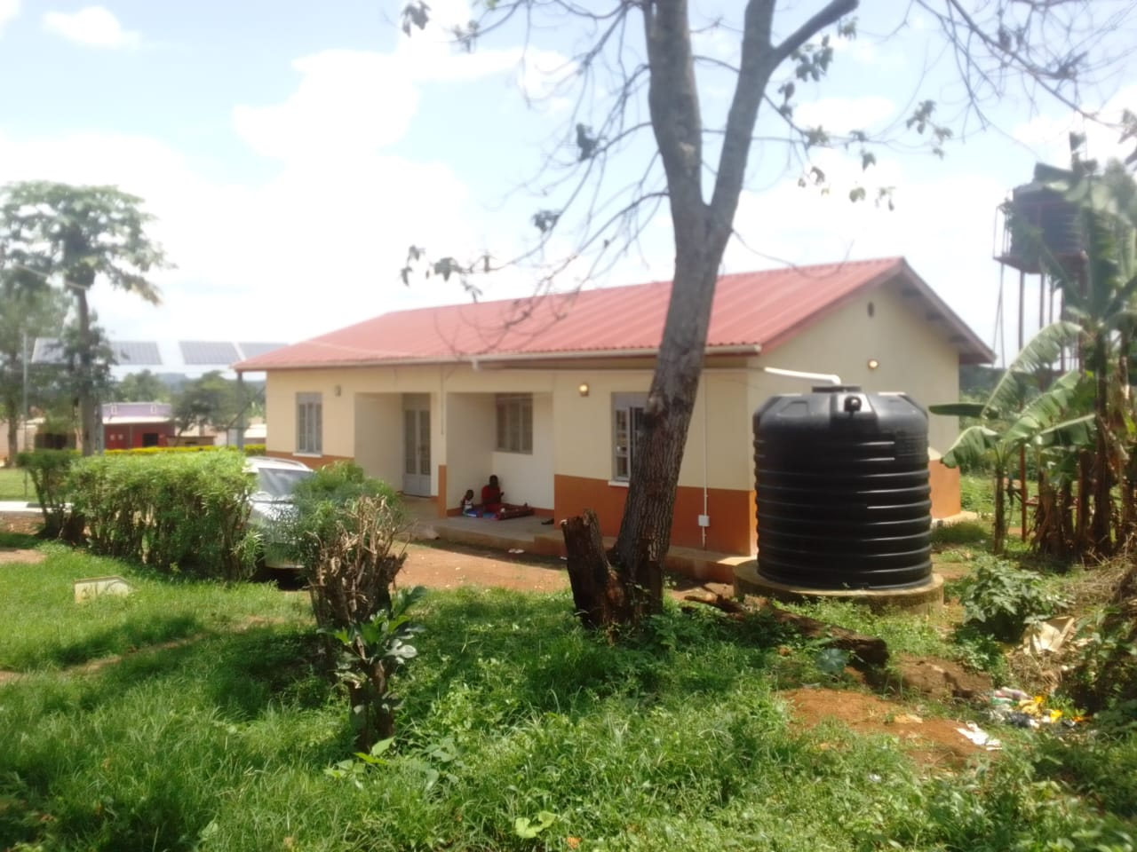
6 STANCE LINED PIT LATRINE | 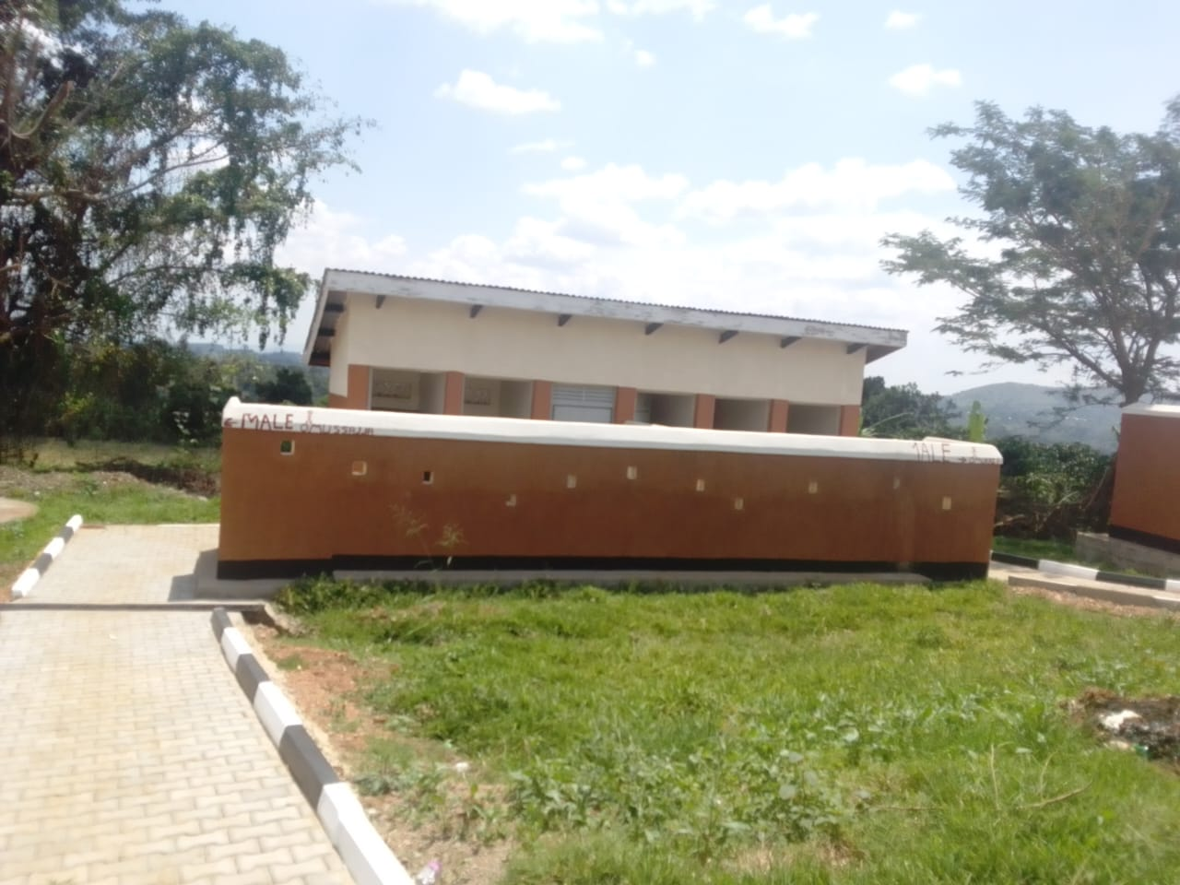
MATERNITY BUIL

DING WITH A WASTE PIT AND A PLACENTA PIT

MATERNITY BUIL  DING WITH A WASTE PIT AND A PLACENTA PIT | 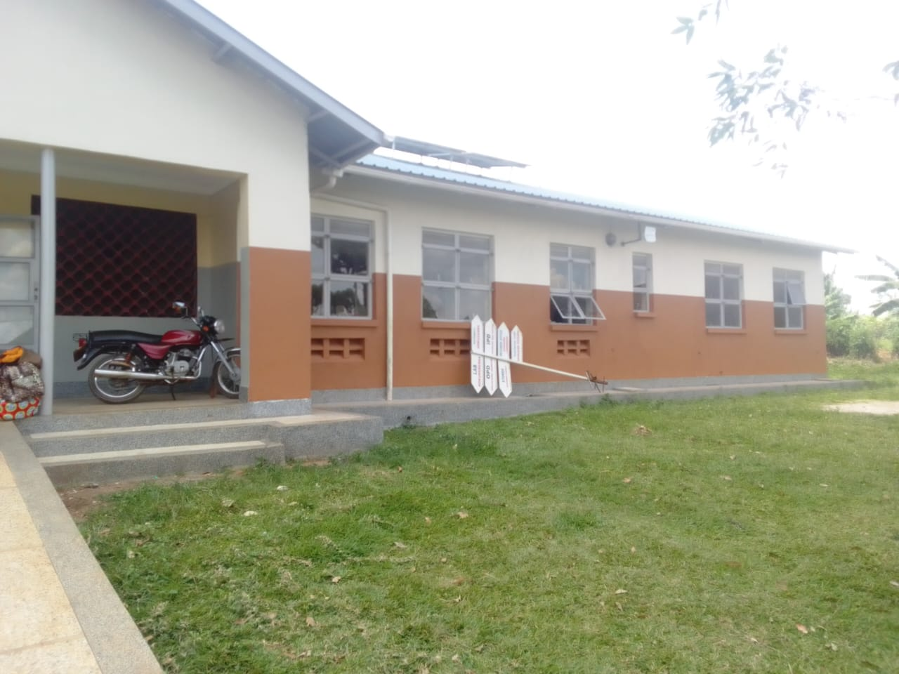
PACENTA PIT | 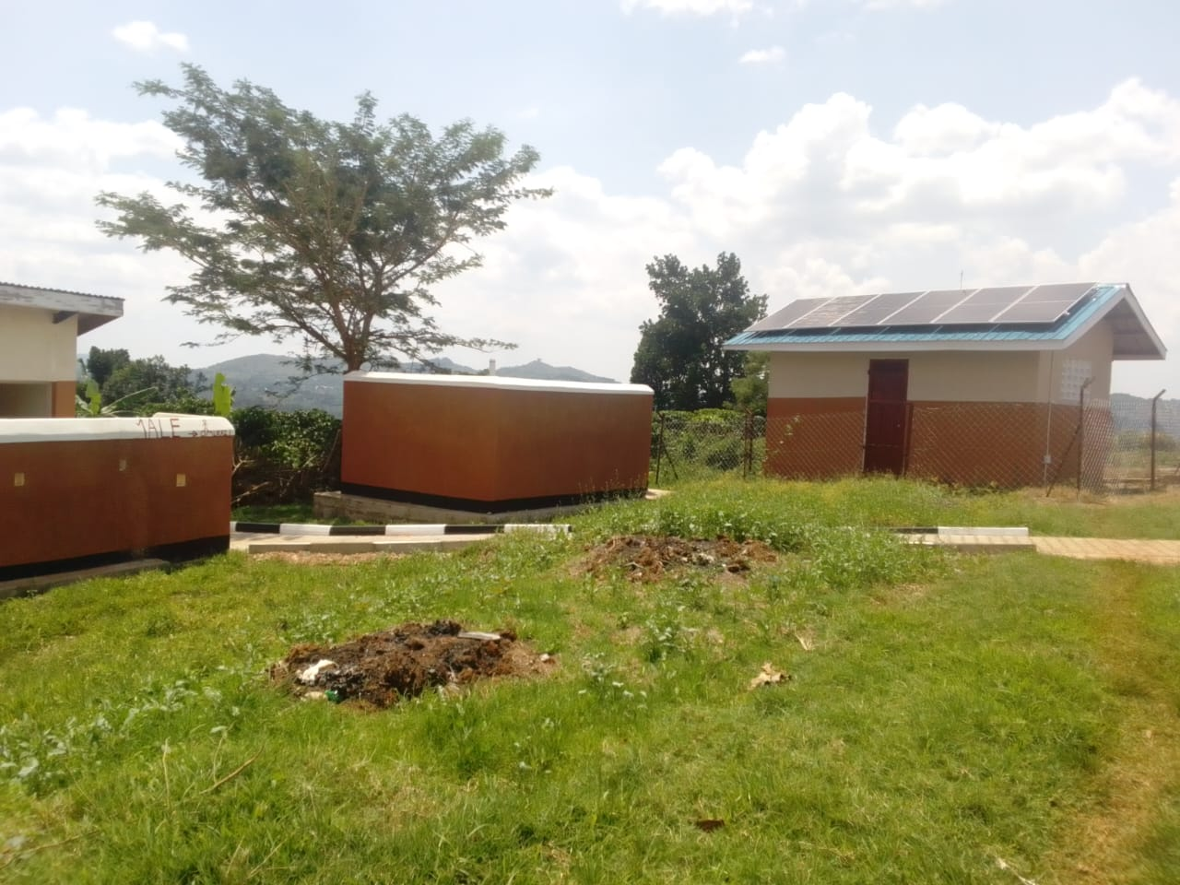
A FENCED SOLAR HOUSE, WITH BATTERIES | 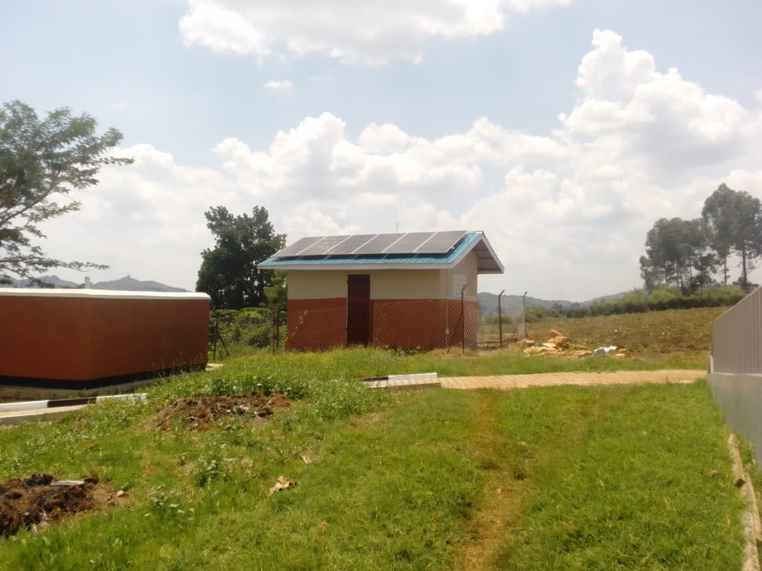
Sample of benches, not engraved | 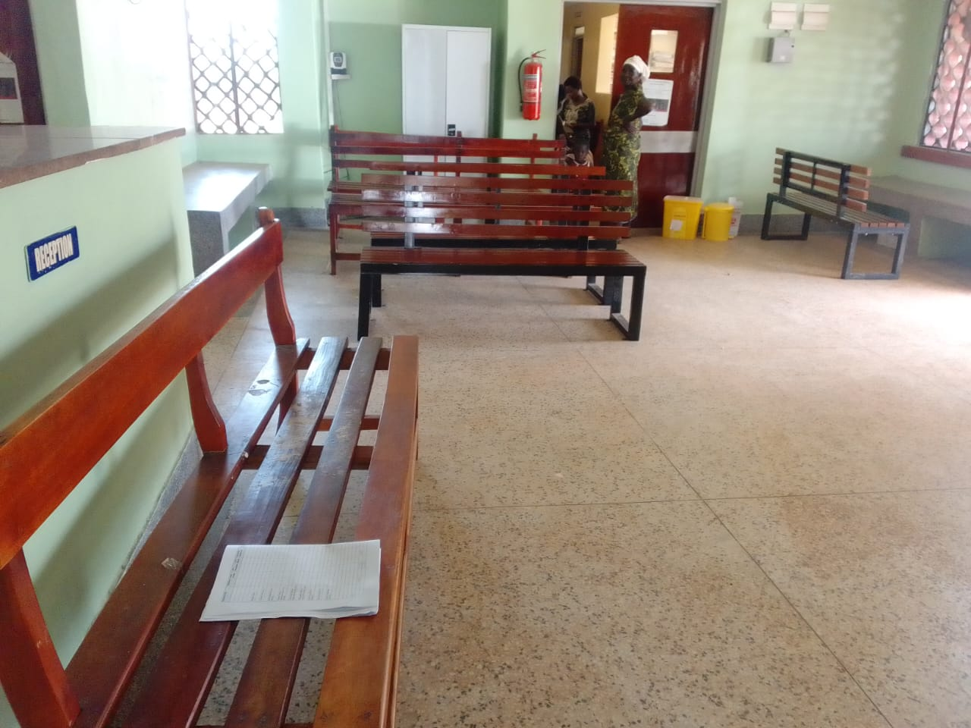
Refrigerator | 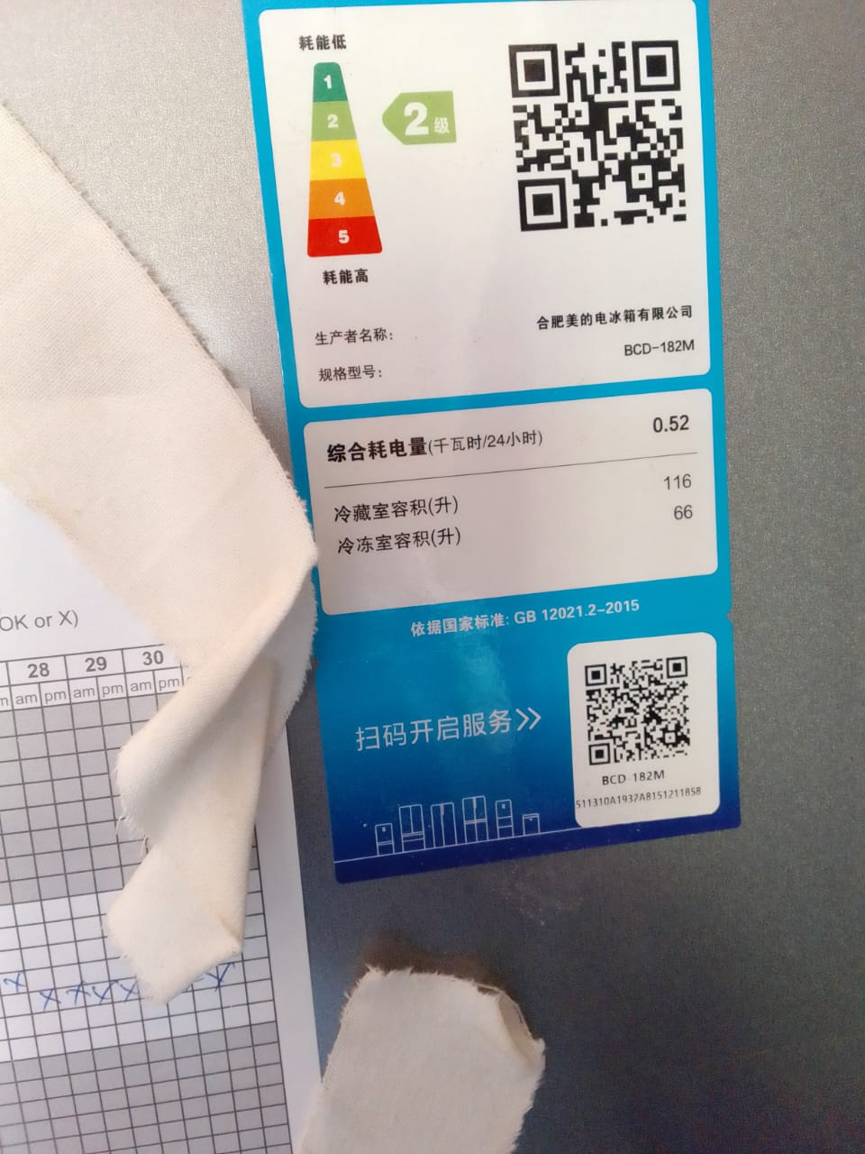
Microscope binocular | 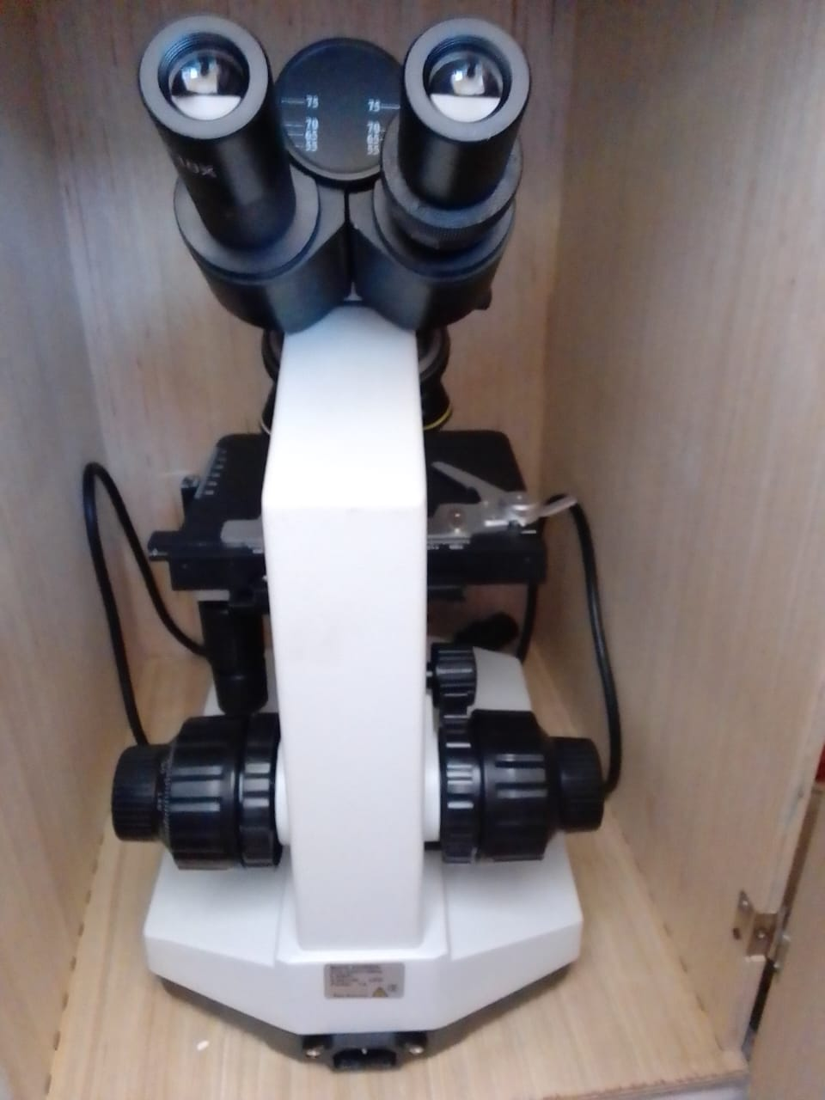
centrifuge | 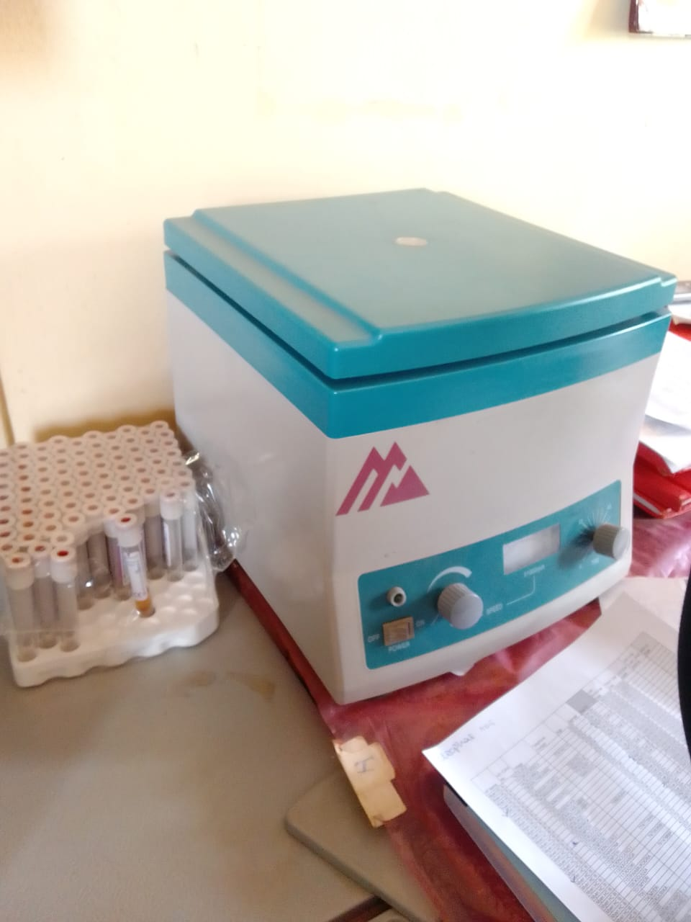
Hemoglobin meter | 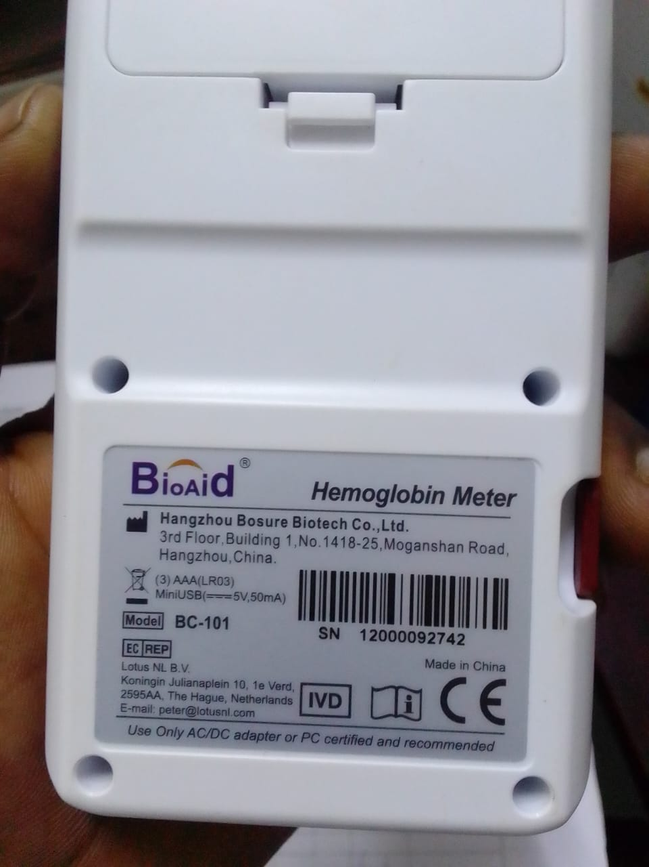
Sample of baby cot, and cupboard with glass | 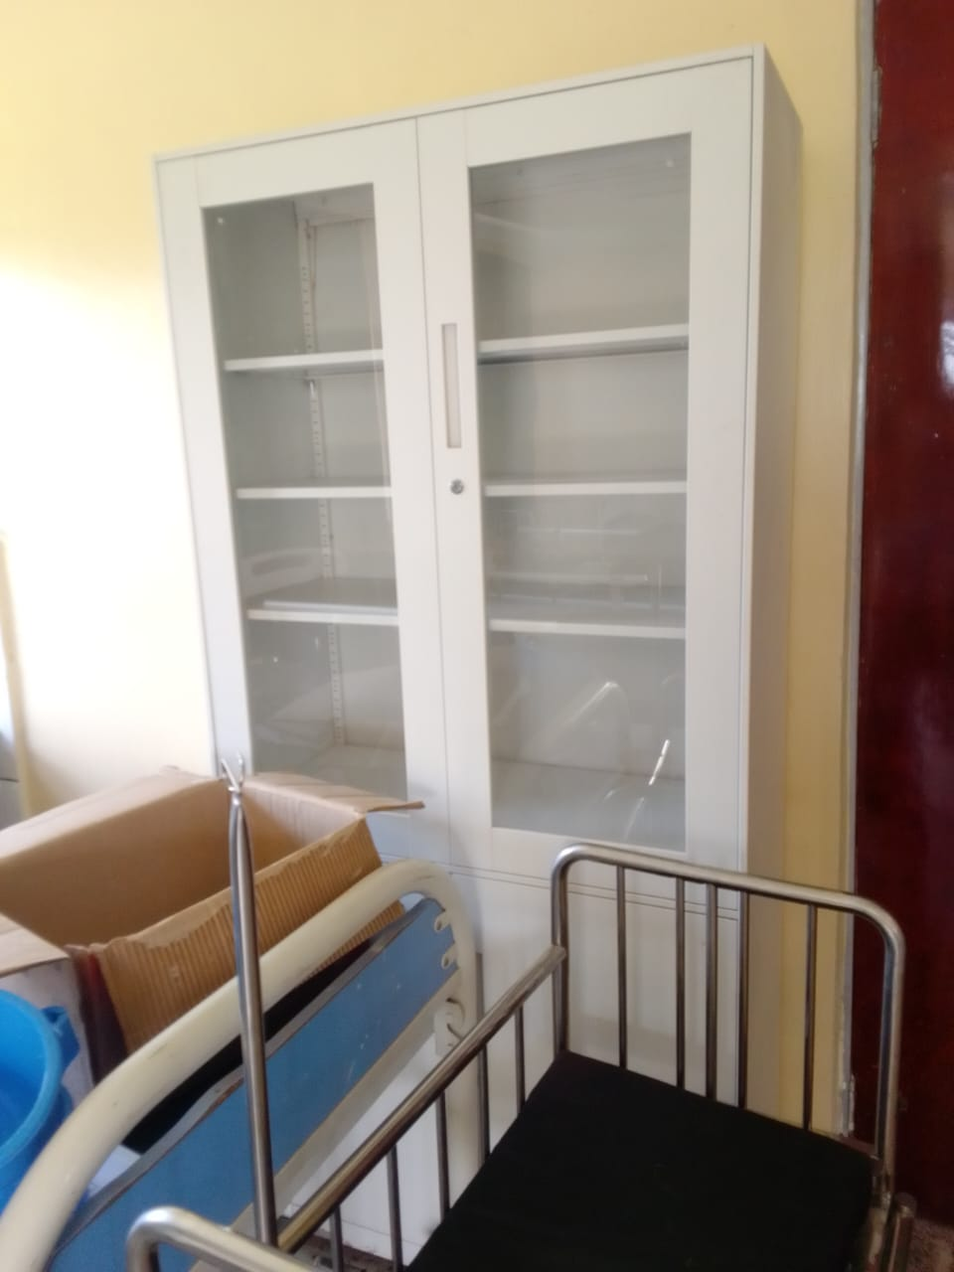
Patient beds, mattress and patient screens in the store | 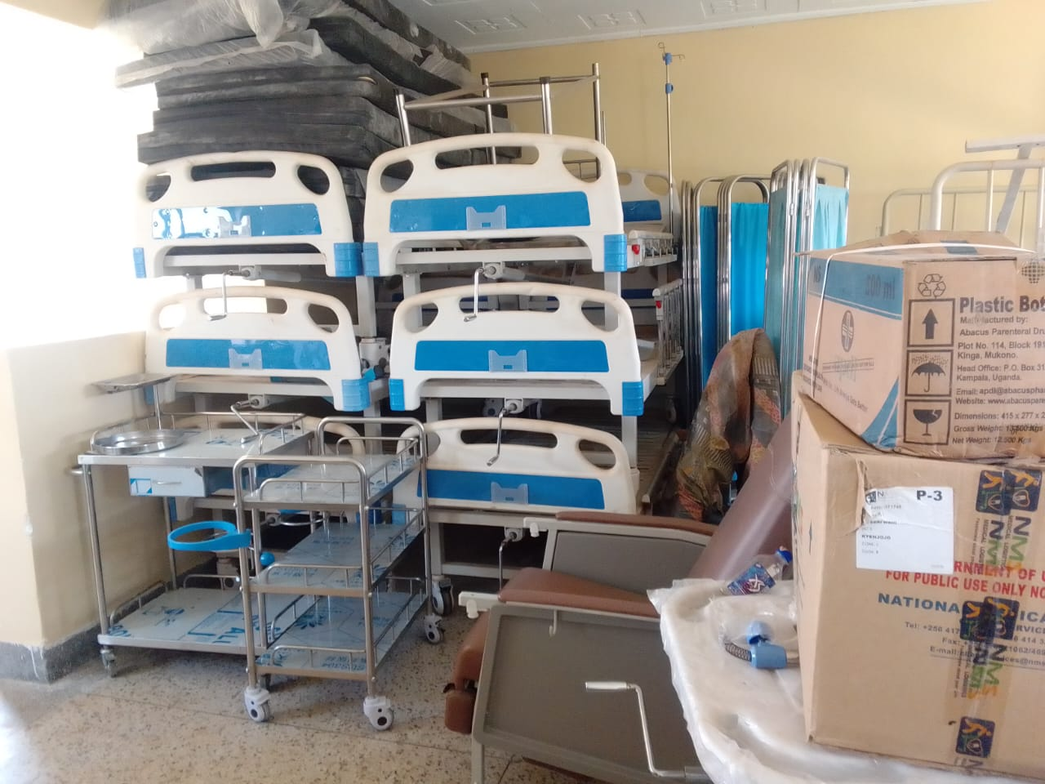
Oxygen concetrator | 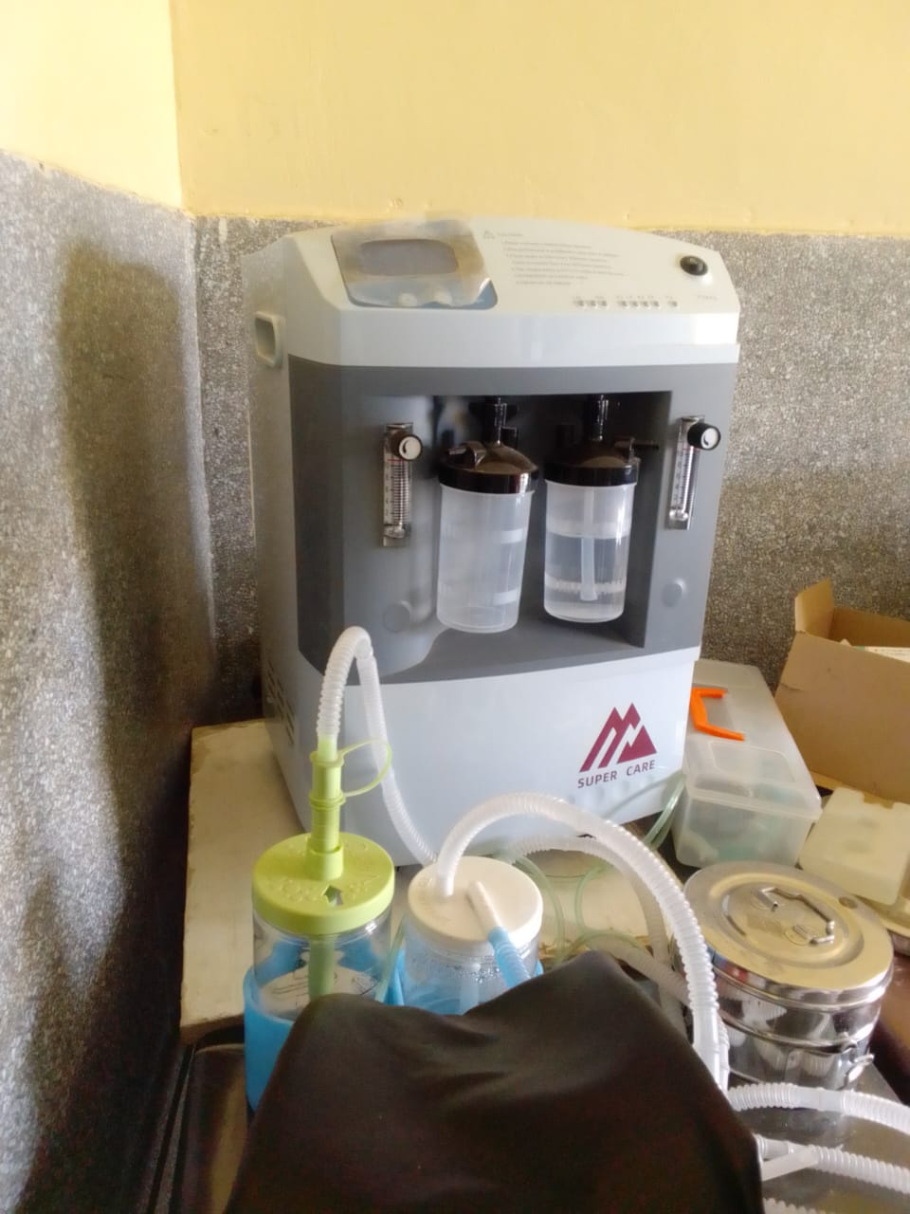
Instrument trolley | 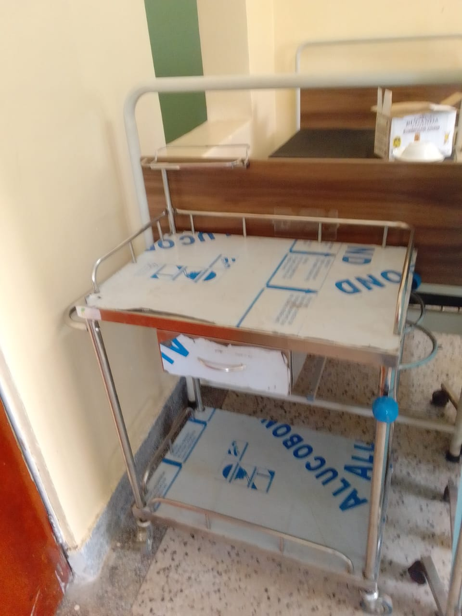
Sample of Stretcher, with drip stand and beds in the store | 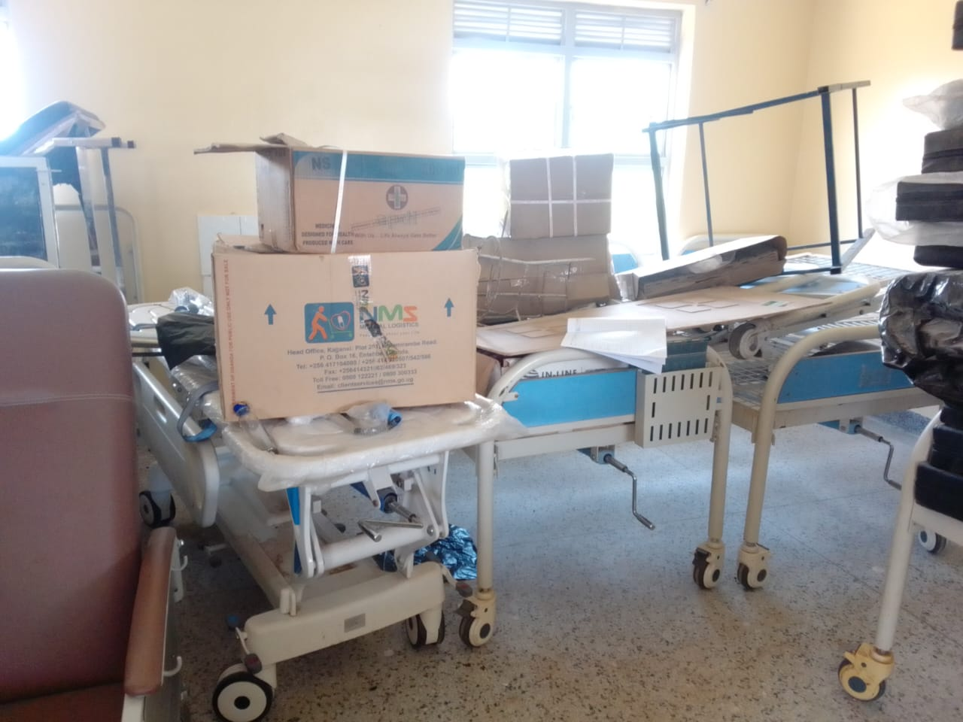
Sample of pedriatic beds with drip stands | 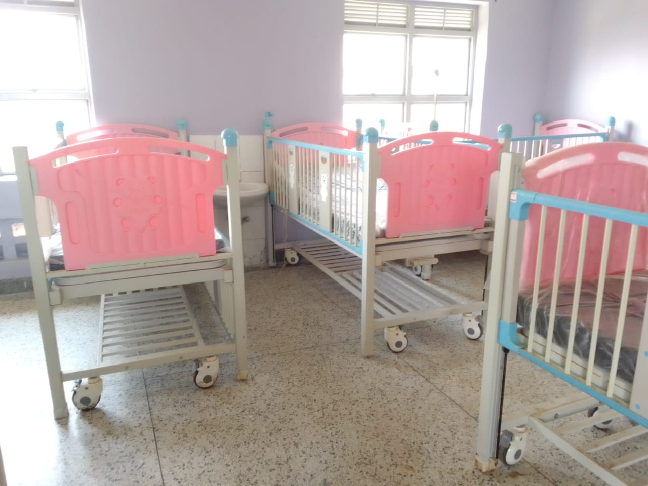
Sample of drip stand and examination lights | 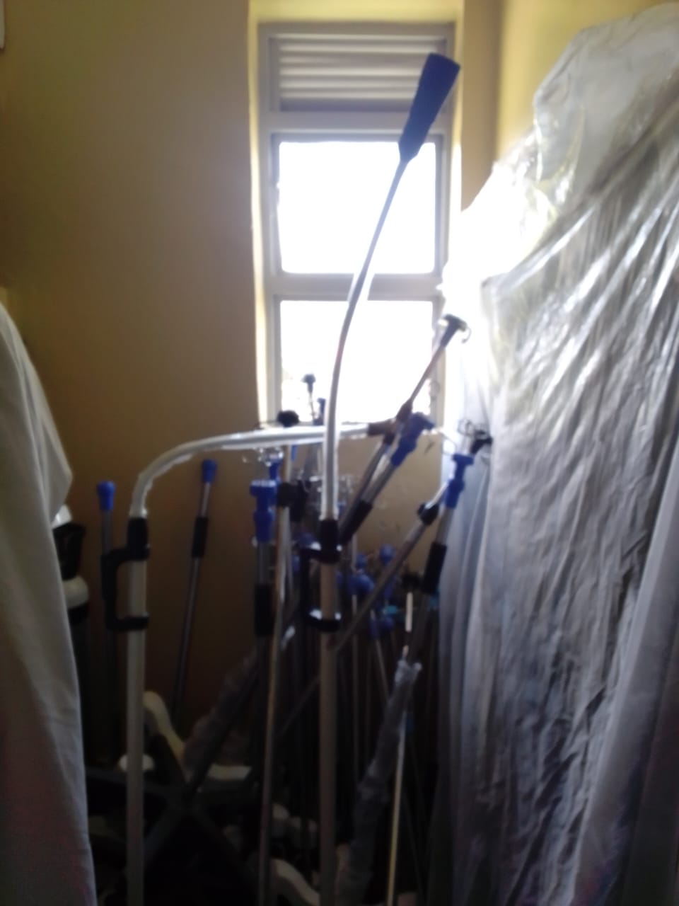
Kangaroo mother care chair still in the box | 